MultiVariate Coherence User's Guide
Home Training Version

Multivariate coherence trains the coherence relation between 4 separate sites on the cortex. The clinicians screen is shown below
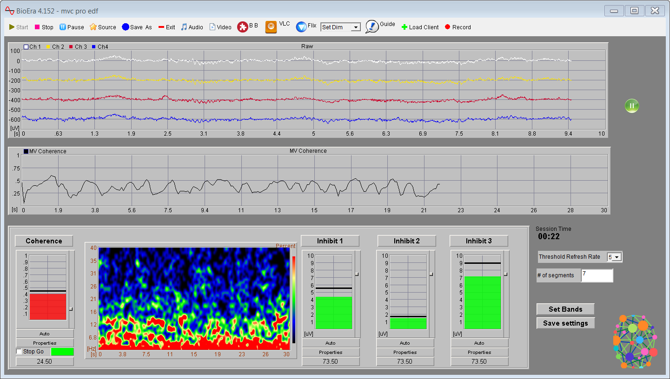
There are menu buttons for control of the session and for control of feedback. Raw waves and the value of the multivariate coherence are shown on the oscilloscopes There is a spectrogram that display relative amplitude values from 0 to 40hz. Session time is visible on the screen. Also on screen are displays that show the number of sessions authorized and the number of sessions remaining and one that indicates when the design is playing or paused. The Control Panel is blinded in the Home Training version and requires a password to be shown.

Shown below the menu tool bar.

Some Buttons are not used for home training

The design displays data automatically when it is loaded, no data is recorded

*Start button is used only to restart after a pause in the session.
*Stop button stops data processing and feedback, A new session must be created after using it
*Pause button pauses data processing and feedback but allows for processing to resume.
*Exit closes the design and saves recorded data.
*Audio button brings up a panel for selection of MP3 or midi feedback.
*Video button brings up the built in video player.
*BB button loads the BrainsBreaker puzzle.
*VLC loads the VLC media player used for DVDs
*Flix button allows control of play/pause on a browser Netflix or Amazon Prime video
*Dim dropdown allows dimming of the screen in conjunction with CareUEyes
*Guide displays which sites are being trained
*Record brings up the data recording window

Starting

Plug in and start the Neurobit amp

When the design first starts there will be a signal coming from the amplifier. It will be displayed on the oscilloscope at the top of the design window.

From here you can enter the name of a new client or select an existing client from the drop down menu. Once that is done clicking OK saves a new client or selects an existing client sand starts recording session data. A piano chord will play indicating that the session has started.

Thresholds
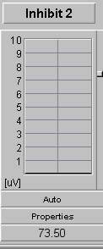
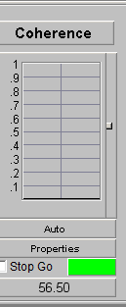
The threshold bar is green when the signal is in desired range. It turns red when the range is exceeded. Positive feedback is provided when all bars are green

Guide

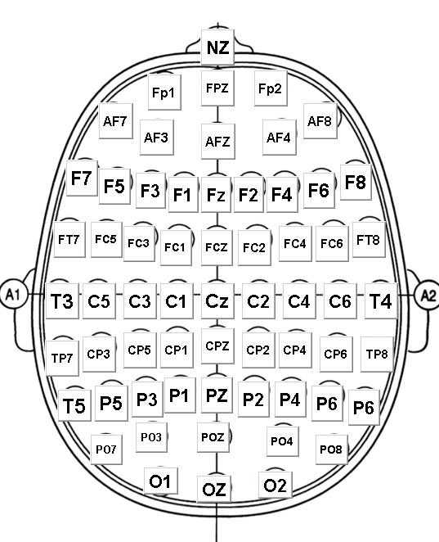

Click the button on the sites to be trained. Users can use as a reminder as to which sites are being trained for the client,
Guide

Feedback controls

*Built in Video player

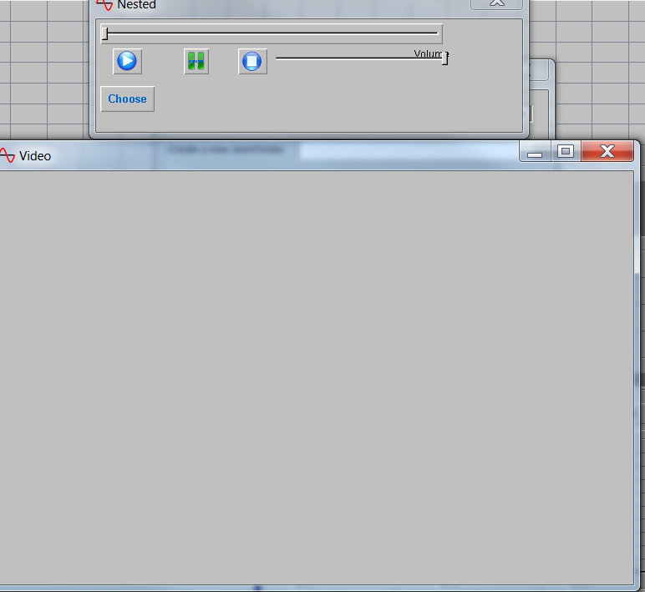

From here you choose a video to play. On some videos the slider at the top of the panel will allow the user scroll forward or back in the video. The same is true for the volume of the video is there is a sound track.
The video will play in the rectangular window labeled Video.
.
*Audio Player

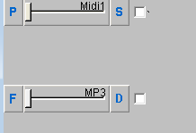

Allow you to set audio feedback you can chose midi by clicking P Settings in clued rate of play, Key, and midi instrument. The slider controls volume. Check box must be checked to start playing.
*MP3 player. Click F to select the MP3 file you wish to play. Click D to set the amount the volume will drop when thresholds are not met.

Set Dim
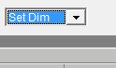
This dropdown menu item controls the dimming function for feedback. It uses a small utility called CareUEyes to control screen brightness

The record button brings up a screen to choose an existing client from a drop down list or enter a new client in the text box
Clicking the OK button begins recording data to that clients folder and starts the session timer clock.

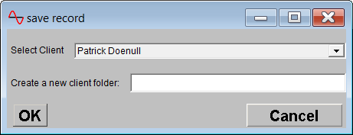

When a design is saved with the clients name and settings it can be opened from the load design button.
When all settings have been made the design can be saved with the clients name using the save as button. It can then be opened later from the load client button

